[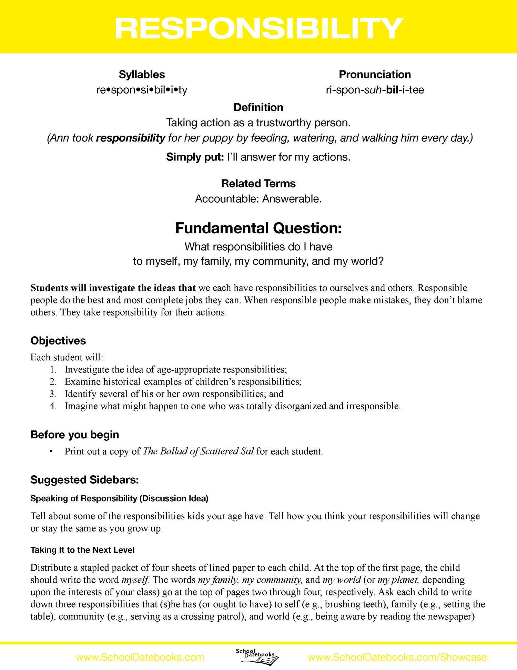](http://showcase.schooldatebooks.com/s/LessonPlan-Responsibility.pdf)